Pr1.1 | import java.util.Scanner;  public class VendingMachine{  enum Coin{  ONE, TWO, FIVE, TEN  }  public static void main(String[] args) {  int snackPrice = 15;  int totalAmount = 0;  int coinValue = 0;  Scanner sc=new Scanner(System.in);  while (totalAmount<snackPrice) {  System.out.print("Enter coin (ONE, TWO, FIVE, TEN): ");  String input = sc.next();  Coin coin = null;  switch (input) {  case "ONE":  coin = Coin.ONE;  break;  case "TWO":  coin = Coin.TWO;  break;  case "FIVE":  coin = Coin.FIVE;  break;  case "TEN":  coin = Coin.TEN;  break;  default:  System.out.println("Invalid Coin!");  continue;  }  switch (coin) {  case ONE:  coinValue=1;  break;  case TWO:  coinValue=2;  break;  case FIVE:  coinValue=5;  break;  case TEN:  coinValue=10;  break;  }  totalAmount += coinValue;  System.out.println("Total paid: " + totalAmount);  }  System.out.println("Paid. Change: " + (totalAmount-snackPrice));  sc.close();  } }
Output | 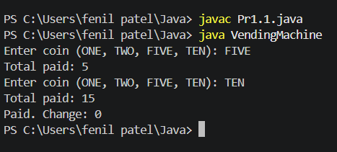
Pr1.2 | import java.util.Scanner;  public class TollBooth{  record Vehicle(String number, String type){}  public static void main(String[] args){  Scanner sc=new Scanner(System.in);  int totalToll=0;  int bikeCount=0;  int carCount=0;  int truckCount=0;  while(true){  System.out.print("Enter vehicle number (or done to stop): ");  String number = sc.next();  if (number.equals("done")){  break;  }  System.out.print("Enter vehicle type (bike/car/truck): ");  String type = sc.next();  Vehicle vehicle = new Vehicle(number, type);  switch (vehicle.type()){  case "bike":  totalToll+=20;  bikeCount++;  break;  case "car":  totalToll+=50;  carCount++;  break;  case "truck":  totalToll+=150;  truckCount++;  break;  default:  System.out.println("Invalid vehicle type!");  }  }  System.out.println("Total toll: " + totalToll);  if(bikeCount>=carCount && bikeCount>=truckCount){  System.out.println("Most frequent: bike");  }  else if(carCount>=bikeCount && carCount>=truckCount){  System.out.println("Most frequent: car");  }  else{  System.out.println("Most frequent: truck");  }  sc.close();  }  }
Output | 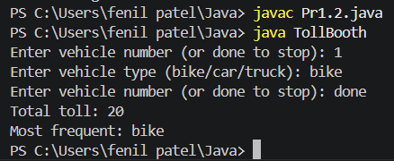
Pr1.3 | import java.util.Random;  import java.util.Scanner;  enum Move {  ROCK, PAPER, SCISSORS, LIZARD, SPOCK  }  class RPSLS {  static int winner(Move p, Move c) {  if (p == c)  return 0;  switch (p) {  case ROCK:  return (c == Move.SCISSORS || c == Move.LIZARD) ? 1 : -1;  case PAPER:  return (c == Move.ROCK || c == Move.SPOCK) ? 1 : -1;  case SCISSORS:  return (c == Move.PAPER || c == Move.LIZARD) ? 1 : -1;  case LIZARD:  return (c == Move.SPOCK || c == Move.PAPER) ? 1 : -1;  case SPOCK:  return (c == Move.SCISSORS || c == Move.ROCK) ? 1 : -1;  }  return 0;  }  public static void main(String[] args) {  Scanner sc = new Scanner(System.in);  Random r = new Random();  int playerScore = 0, computerScore = 0;  for (int i = 1; i <= 5; i++) {  System.out.print("Enter move (ROCK/PAPER/SCISSORS/LIZARD/SPOCK): ");  Move player = Move.valueOf(sc.next().toUpperCase());  Move computer = Move.values()[r.nextInt(5)];  System.out.println("Computer: " + computer);  int result = winner(player, computer);  if (result == 1) {  System.out.println("You win this round!");  playerScore++;  } else if (result == -1) {  System.out.println("Computer wins this round!");  computerScore++;  } else {  System.out.println("Round Draw!");  }  System.out.println();  }  System.out.println("Your Score = " + playerScore);  System.out.println("Computer Score = " + computerScore);  if (playerScore > computerScore)  System.out.println("You win!");  else if (computerScore > playerScore)  System.out.println("Computer wins!");  else  System.out.println("Match Draw!");  sc.close();  }  }
Output | 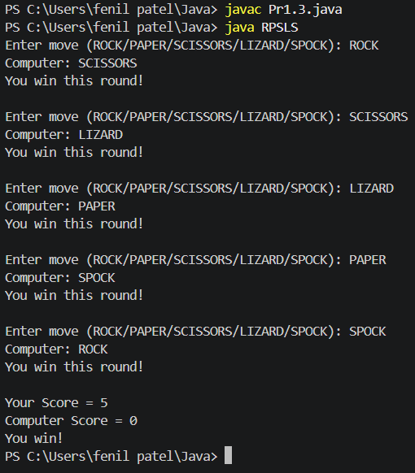
Mini Project | import java.util.Scanner;  class MiniBank {  record BankInfo(String name, String branch) {}  enum MenuOption {  OPEN_ACCOUNT,  DEPOSIT,  WITHDRAW,  TRANSFER,  EXIT  }  public static void main(String[] args) {  Scanner scanner = new Scanner(System.in);  BankInfo bankInfo = new BankInfo("MiniBank", "Petlad Branch");  System.out.println("=================================");  System.out.println(" " + bankInfo.name());  System.out.println(" Branch: " + bankInfo.branch());  System.out.println("=================================");  while (true) {  System.out.println("\n------ Main Menu ------");  System.out.println("1. Open Account");  System.out.println("2. Deposit");  System.out.println("3. Withdraw");  System.out.println("4. Transfer");  System.out.println("5. Exit");  System.out.print("Enter your choice: ");  int choice = scanner.nextInt();  String message = switch (choice) {  case 1 -> "Open Account - To be implemented in a later lab.";  case 2 -> "Deposit - To be implemented in a later lab.";  case 3 -> "Withdraw - To be implemented in a later lab.";  case 4 -> "Transfer - To be implemented in a later lab.";  case 5 -> "Thank you for using MiniBank. Goodbye!";  default -> "Invalid choice! Please try again.";  };  System.out.println(message);  if (choice == 5) {  break;  }  }  scanner.close();  }  }
Output | 